**Online Visit Options**

Why online visit videos?  
  
+ Budget Friendly   
+ Can use any day through the school year purchase  
+ Perfect as a backup to a no show assembly or surprise activity  
+ Can be shown multiple times within the time frame  
+ Can be used in individual classrooms  
+ Great for a rainy day activity  
+ A good introduction to authors without the hassle of scheduling or rescheduling due to ND weather

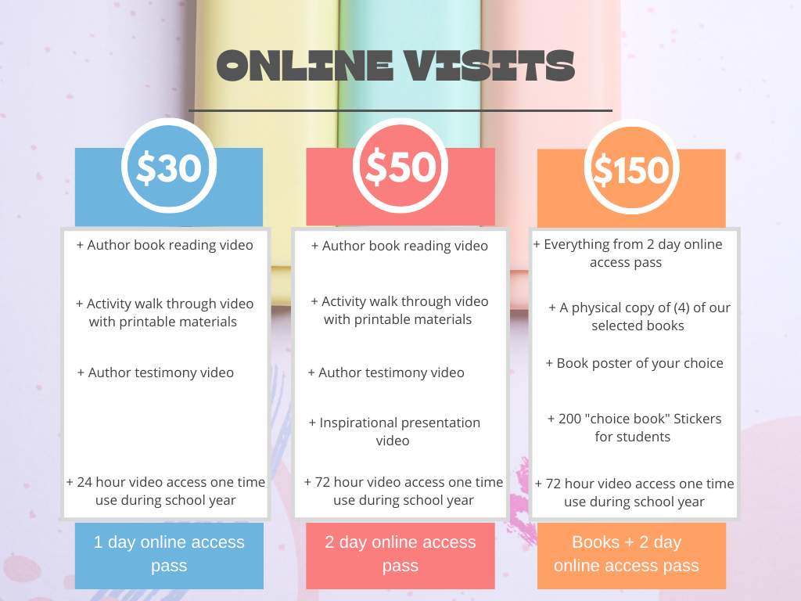  
+ For online or E – visits only, no physical appearance will be made  
You will have access to our exclusive author videos for the time selected, good for the school year you purchase in. For purchasing or further questions please contact; [achoicebook@gmail.com](mailto:achoicebook@gmail.com)